MAJORETTE SPORT WORLD FEDERATION
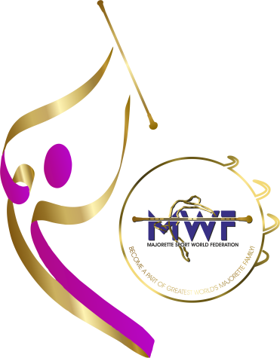
SEMINAR
FOR INTERNATIONAL COACHES
ZAGREB/CROATIA
24.-26.10.2025.

REGISTRATION FORM
Deadline /20.09.2025.

E-mail: mwfeducation1@gmail.com
NAME AND SURNAME:
DATE OF BIRTH:
NATIONAL ASSOCIATION:
TEAM:
YEARS OF WORKING IN THE TEAM:
SEMINAR FOR INTERNATIONAL COACHES : a)first b)second
ADRESS:
MOBILE NUMBER:
E-MAIL:
RESPONSIBLE PERSON:
MOBILE NUMBER:
E-MAIL:

